Owen Lindsey

Professor Sparks, James

09/29/2024

CST-391

Participation Lab T01D07

**Lab 1: Modify the Music DB**

*Adding* ***notes*** *field to albums* ***table*** *within the database* ***music*** *with varchar of 1000.*

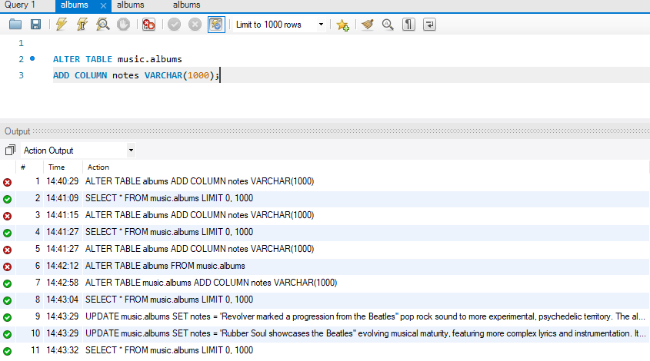

**Lab 1: Modify the Music DB**

*Updating* ***notes*** *field in the table* ***albums*** *where* ***id is 1 and 3*** *within the database* ***music****.*   
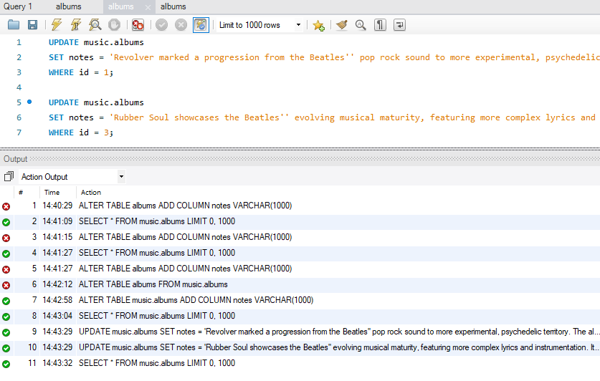

**Lab 2: TypeScript Lab**

Detecting numeric or string input using prompt-sync, with a quit option, in a TypeScript function named detectInput().

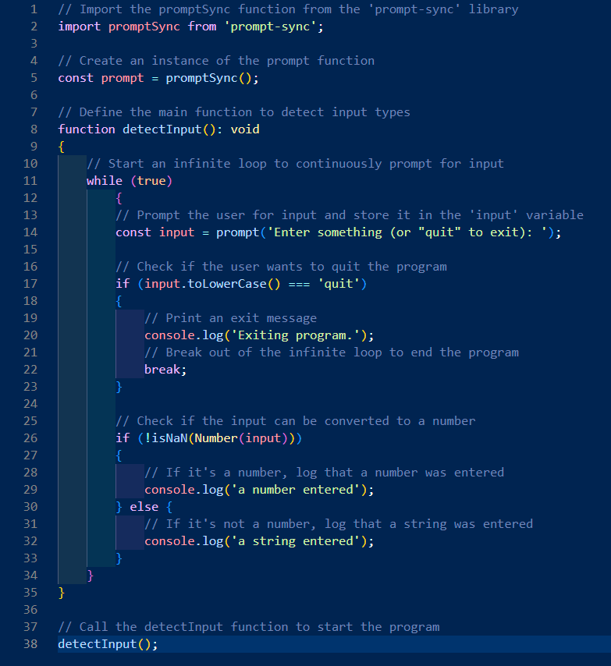

**Lab 2: TypeScript Lab**

Detecting numeric or string input using prompt-sync, with a quit option, output.

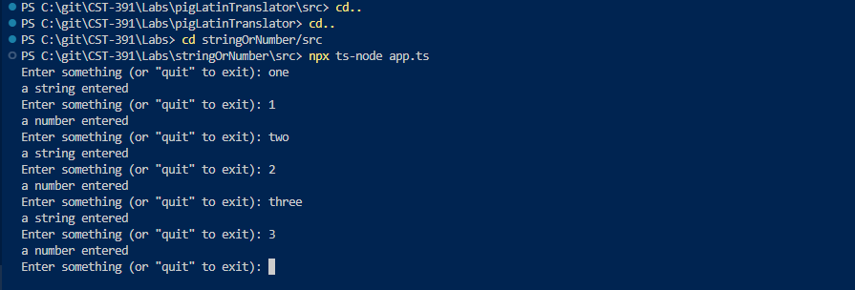

**Lab 3: Pig Latin TypeScript Lab**

Translating words to Pig Latin using TypeScript, with input loop and quit option (1 / 2).

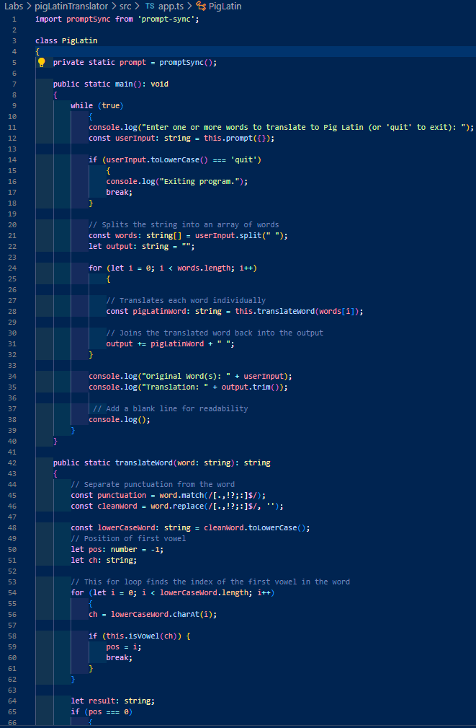

**Lab 3: Pig Latin TypeScript Lab**

Translating words to Pig Latin using TypeScript, with input loop and quit option (2 / 2).

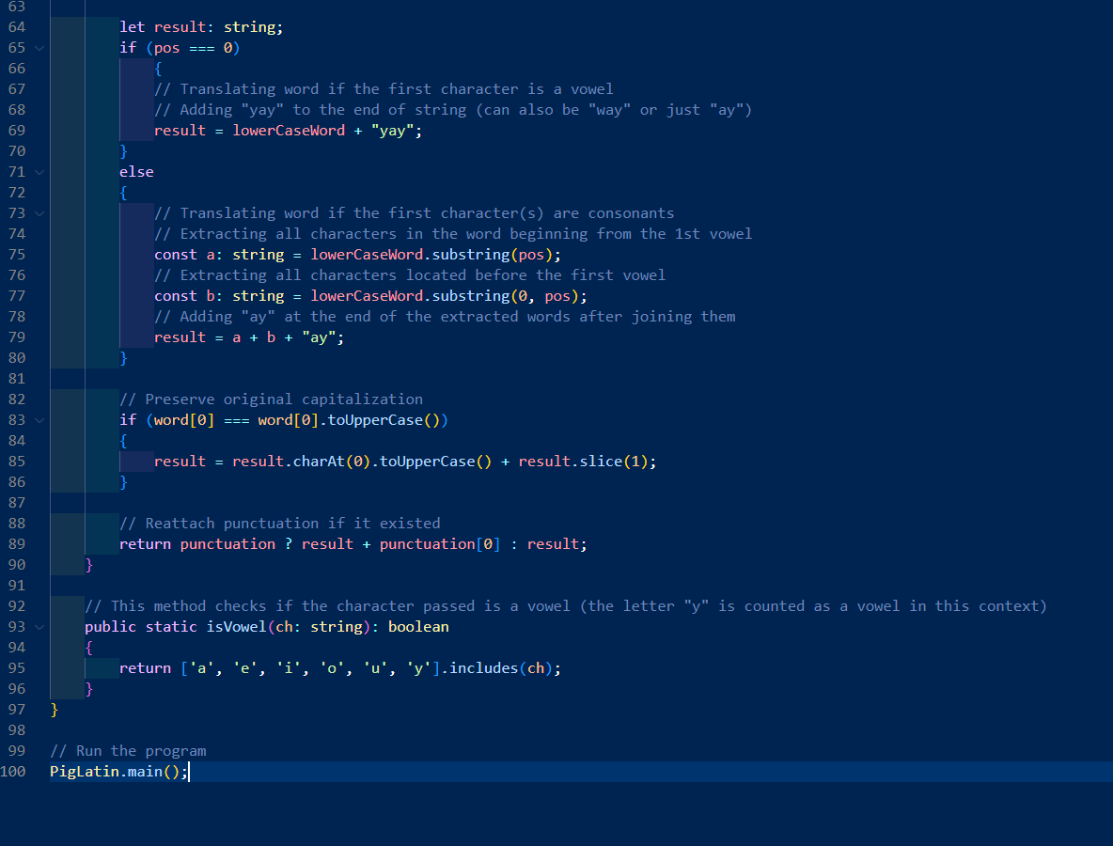

**Lab 3: Pig Latin TypeScript Lab**

Translating words to Pig Latin using TypeScript, output.

(I apologize for the image size; I could not take a larger screenshot of the terminal.)

